Cognizant Deep Skilling - Digital Nurture 4.0 - Week 8
Git Hands-On Lab 1 – Basic Git Operations and Repository Management
Step 1: Setup your machine with Git Configuration
git --version
git config --global user.name "Arunjunai Pandi"
git config --global user.email "arunjunaipandi281@gmail.com"
git config –list
Output:
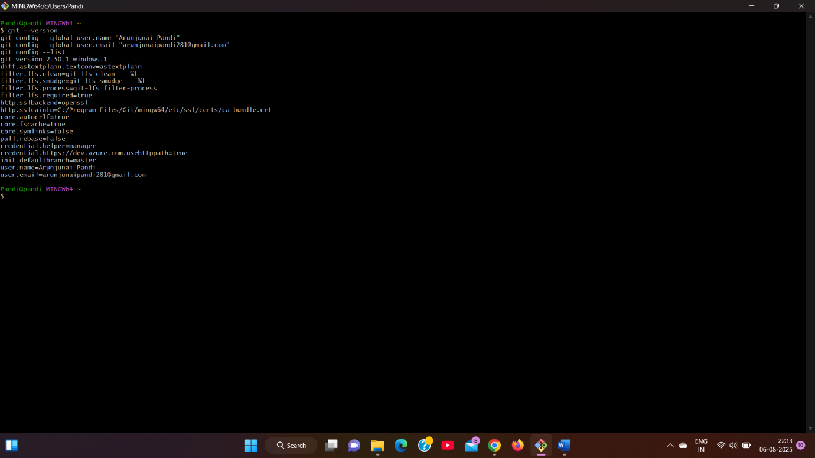
Step 2: Integrate notepad++.exe to Git and make it a default editor

notepad++
git config --global core.editor "\"C:/Program Files (x86)/Notepad++/notepad++.exe\" -multiInst -nosession"
Output:
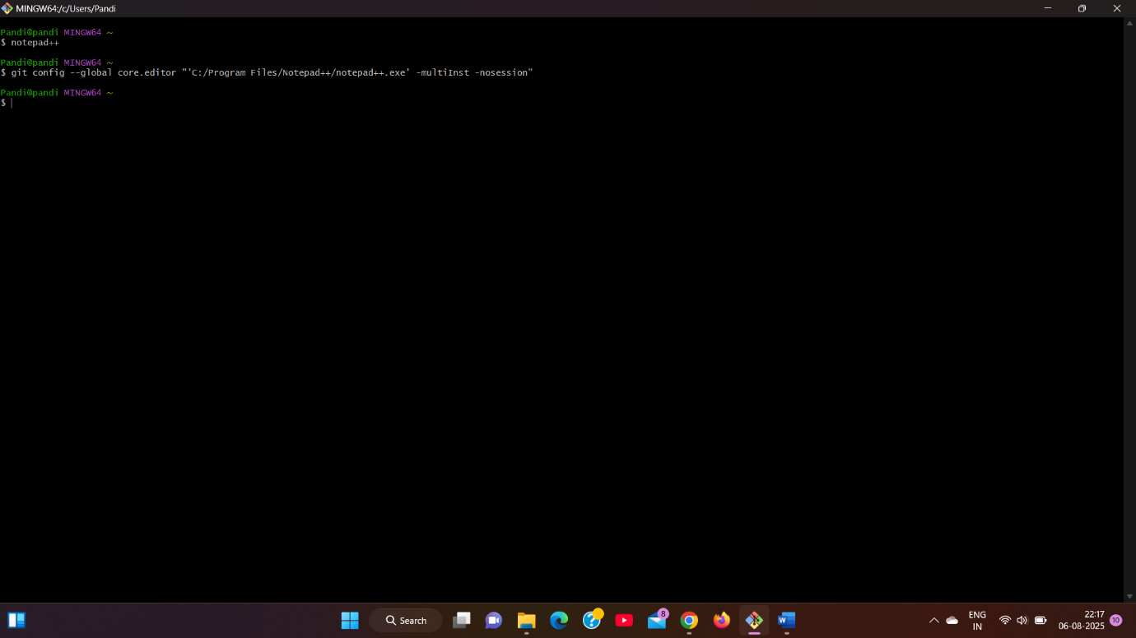
Step 3: Add a file to source code repository
cd ~
mkdir GitDemo
cd GitDemo
git init
echo "Welcome to Git Hands-On Lab" > welcome.txt
ls
cat welcome.txt
git status
git add welcome.txt
git commit
git remote add origin https://gitlab.com/arunjunaipandi281/gitdemo.git
git pull origin master
git push origin master
Output:
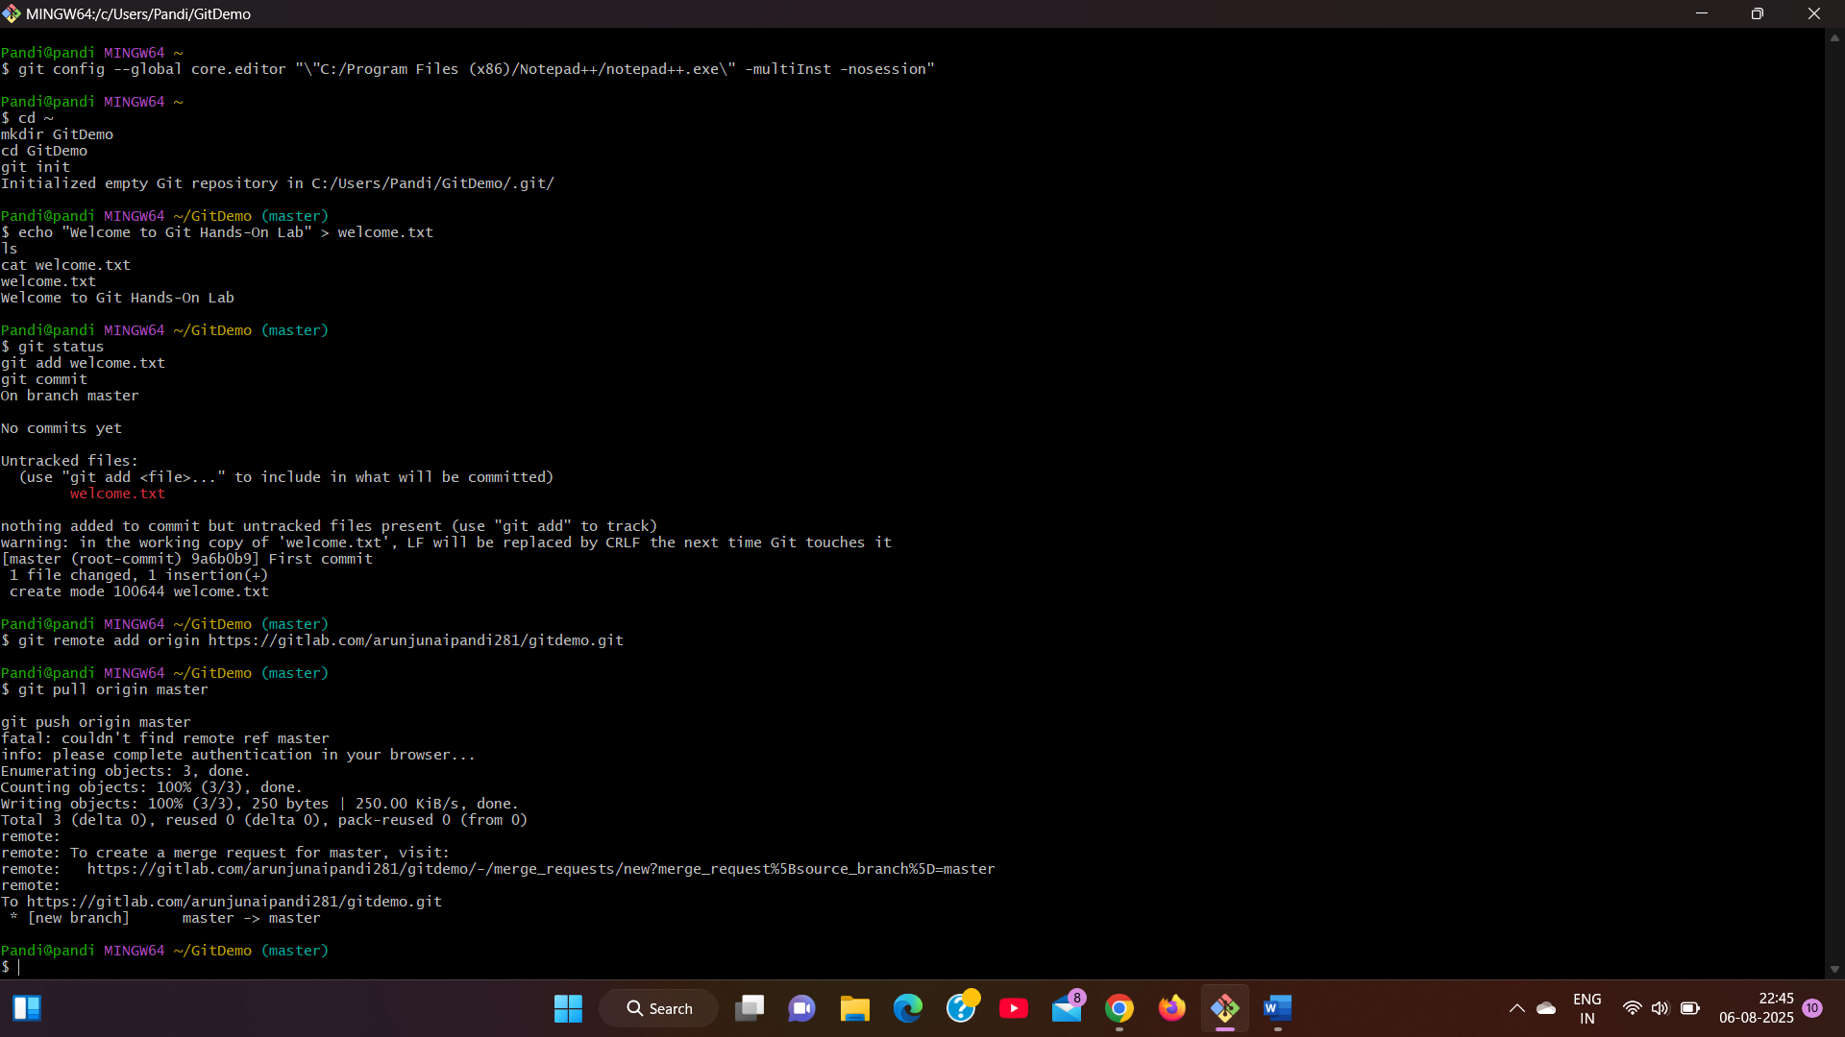
Git Hands-On Lab 2 – Git Ignore
Step 1: Create Unwanted Files
touch debug.log
mkdir log
touch log/system.log
Step 2: Create .gitignore File
touch .gitignore
Add:
*.log
log/
Step 3: Check Git Status
git status
Step 4: Commit and Push
git add .gitignore
git commit -m "Added .gitignore to ignore .log files and log folder"
git push origin master
Output:
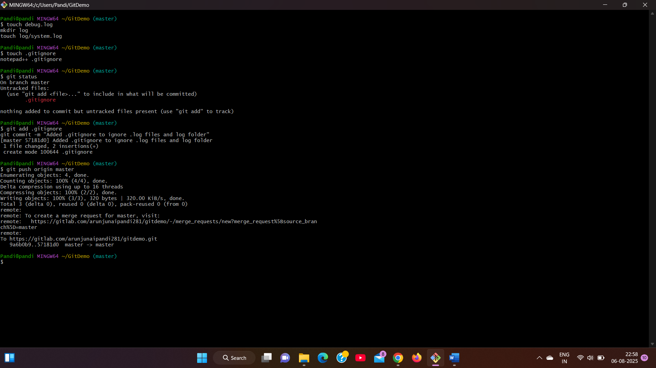
Git Hands-On Lab 3 – Branching and Merging
1. Created New Branch
git checkout -b GitNewBranch
2. Listed Branches
git branch -a
3. Created a File and Committed
echo "This is from GitNewBranch" > branchfile.txt
git add branchfile.txt
git commit -m "Added branchfile.txt in GitNewBranch"
4. Switched Back
git checkout master
git diff master..GitNewBranch
Output:
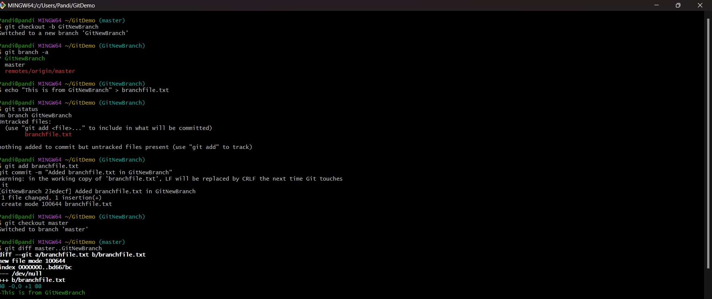
5. Merged
git merge GitNewBranch
6. Checked Logs
git log --oneline --graph –decorate
7. Deleted Branch and Pushed
git branch -d GitNewBranch
git push origin master
Output:
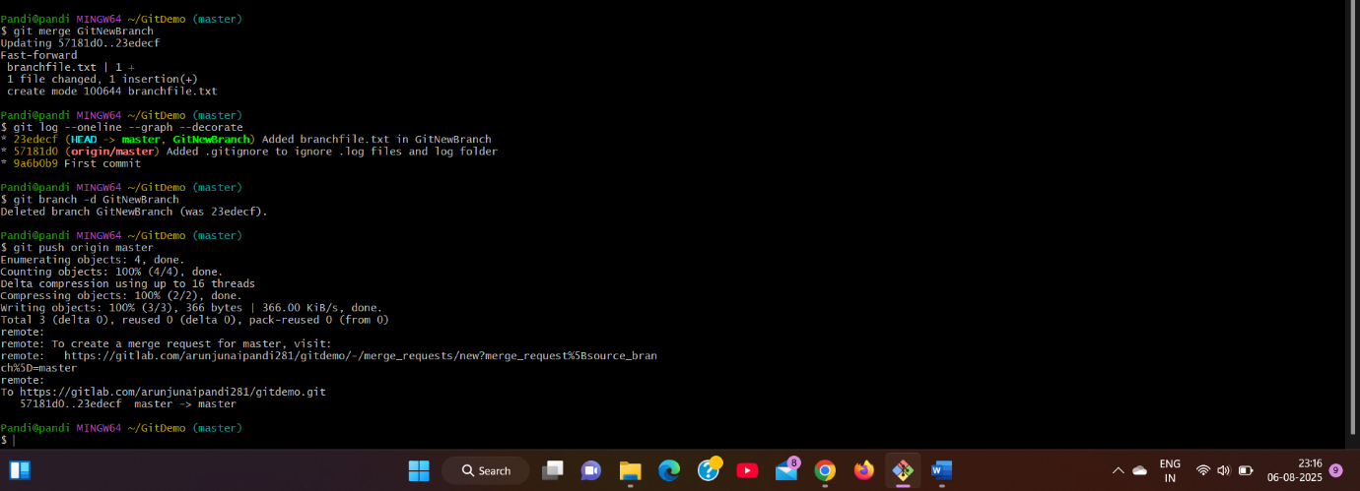
Git Hands-On Lab 4 – Git Merge Conflict Resolution
1. Created a branch GitWork
git checkout -b GitWork
2. Added hello.xml with unique content in GitWork
echo "<message>Hello from GitWork</message>" > hello.xml
git add hello.xml
git commit -m "Added hello.xml in GitWork branch"
3. Switched to master and created conflicting file
git checkout master
echo "<message>Hello from master branch</message>" > hello.xml
git add hello.xml
git commit -m "Added hello.xml in master with different content"
4. Merged and got conflict
git merge GitWork
Output:
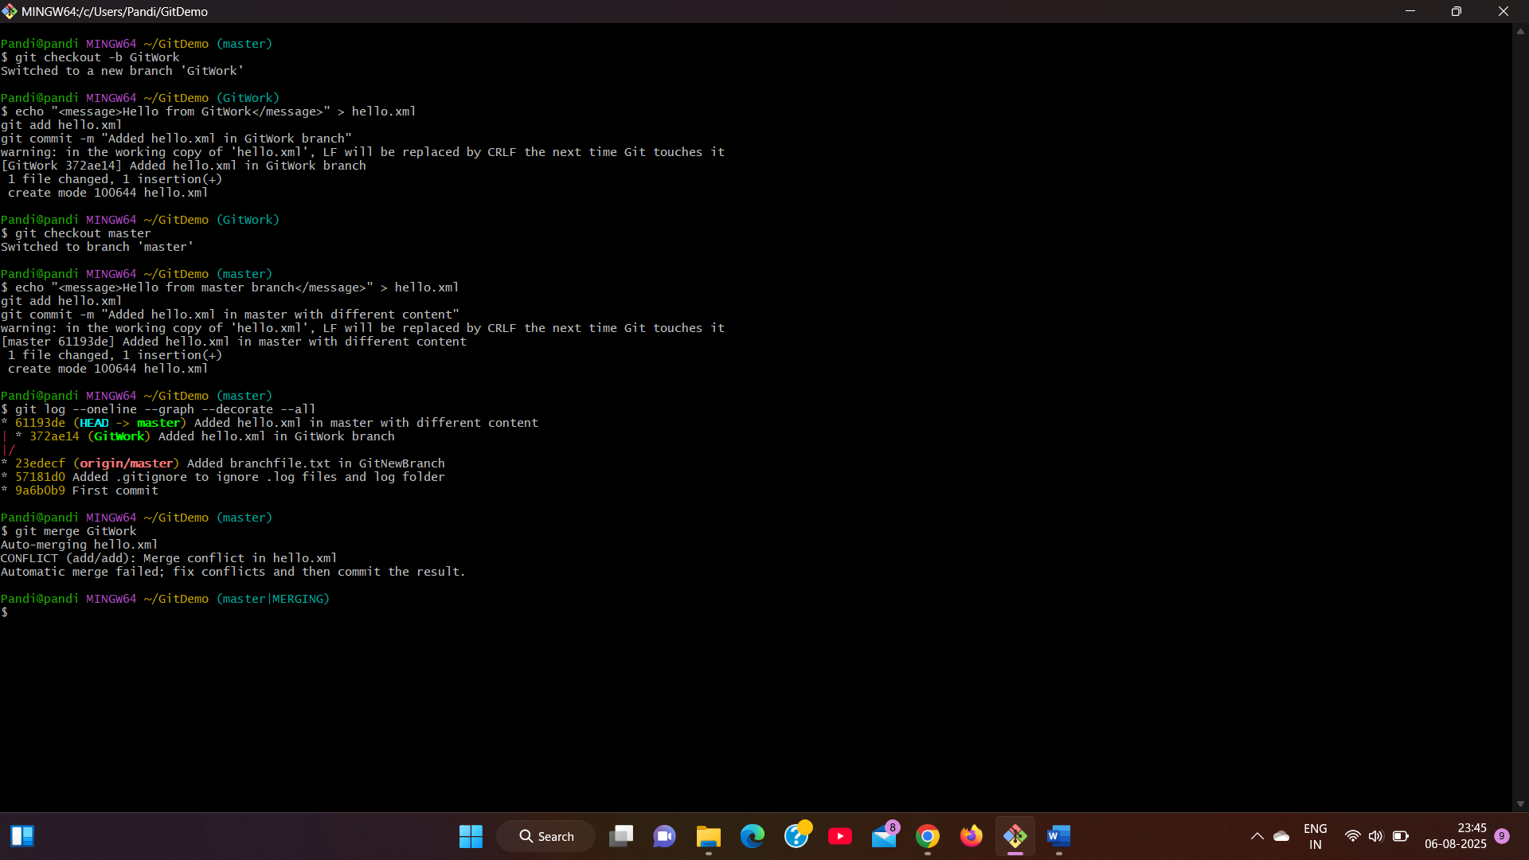
5. Resolved conflict manually and committed
git add hello.xml
git commit -m "Resolved merge conflict in hello.xml"
6. Updated .gitignore and cleaned up
echo "*~" >> .gitignore
git add .gitignore
git commit -m "Updated .gitignore to ignore backup files"
7. Deleted merged branch
git branch -d GitWork
8. View the final graph
git log --oneline --graph --decorate
Output:
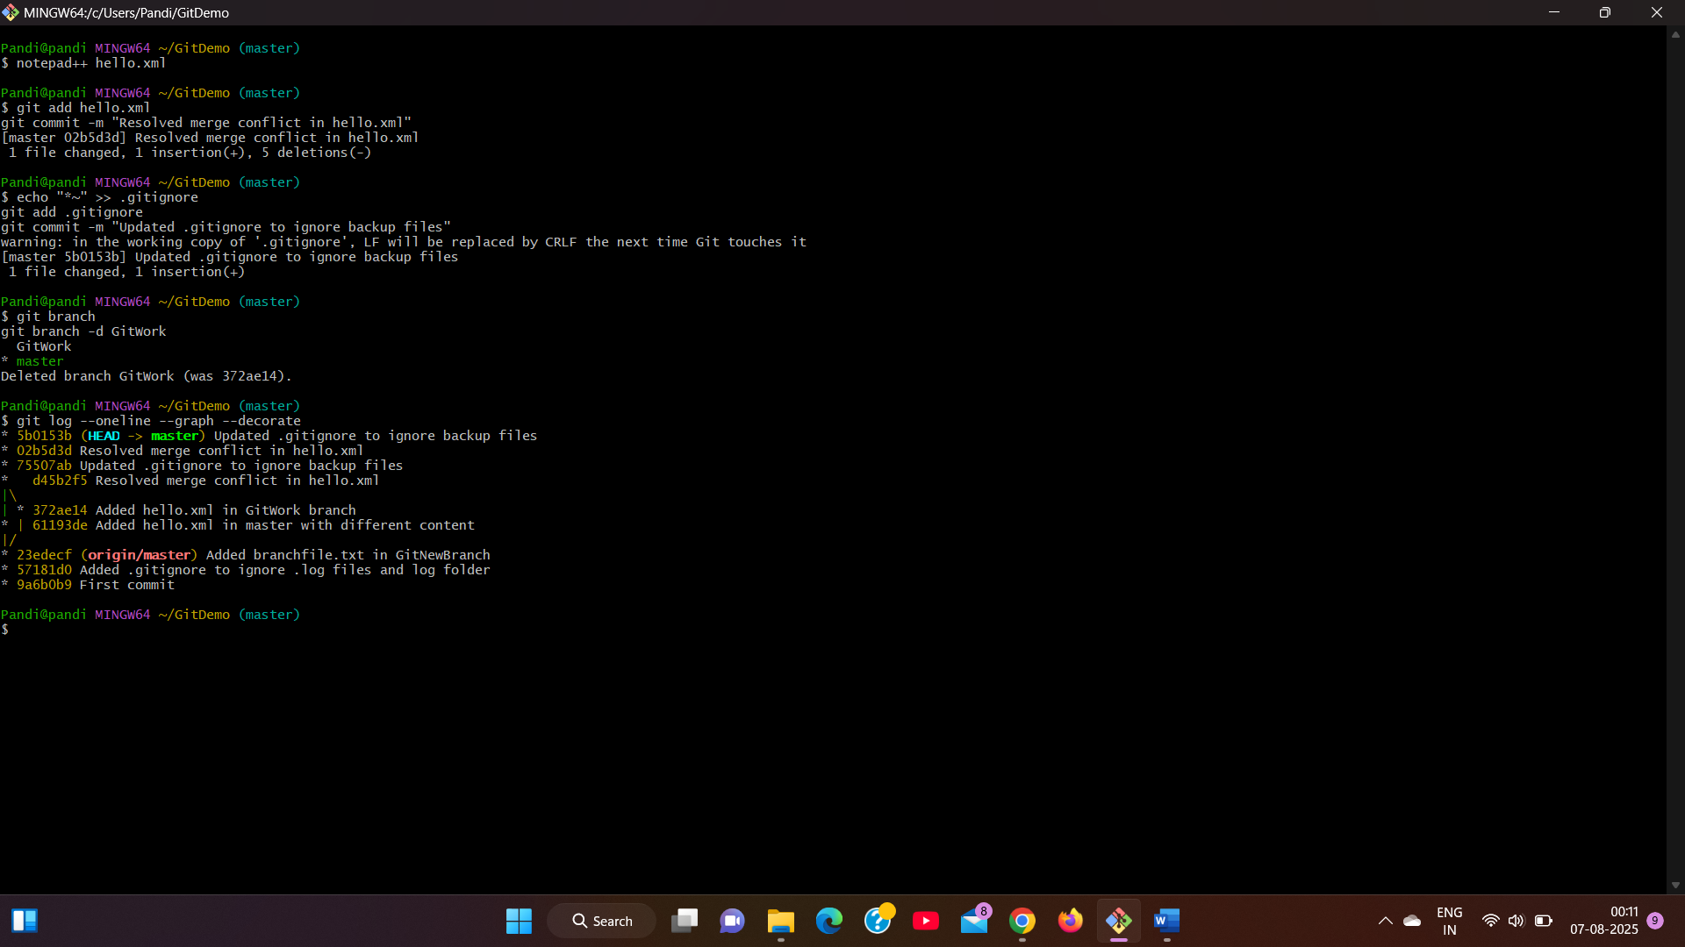
Git Hands-On Lab 5 – Git Cleanup & Push Lab
1. Switched to master branch
git checkout master
2. Checked git status
git status
3. Listed all branches
git branch -a
4. Pulled latest changes
git pull origin master
5. Pushed pending changes
git push origin master
6. Verified updates in GitLab repo
Visited:
https://gitlab.com/arunjunaipandi281/gitdemo
Output:
